Chapter 9
Life in the 13 English Colonies

Lesson 1: Why They Came

Vocab: autobiography, slave trade
People: Jane Hoskens, Olaudah Equiano

*Why people came to the Colonies…*
1. Wealth
2. Freedom of religion
3. Cheap land
4. Better opportunity to make a living (better/more jobs)
5. Some were forced (African slaves, convicts, and indentured servants)
(*indentured servants were “forced” to come because they could not afford to live in England without jobs, high taxes, and high rent.)

*The trip to America was long and hard. People were cramped and the food and water was spoiled.*

*The slave trade began because many farmers in the colonies could not hire enough workers to tend to their crops.

Lesson 2: The Colonial Economy

Vocab: export, import, agriculture, free enterprise, industry, triangular trade, Middle Passage
People: Elizabeth Lucas Pinckney

*Nine out of ten colonists made a living by farming.

Southern Colonies Economy:
*Warm climate and good soil= good for farming
*Much of the farm land was used for cash crops
*They grew and exported tobacco, rice and indigo

Middle Colonies Economy:
*Grew a lot of wheat and corn- known as the breadbasket.
*Sold surplus grain to the West Indies
(West Indies used the grain to feed the slaves working in sugar fields there)

New England Colonies Economy:
*Most New Englanders made a living from the forests or the sea.
*Colonists used the forests for lumber to make ships
*They then sold ships and fish they caught for profit
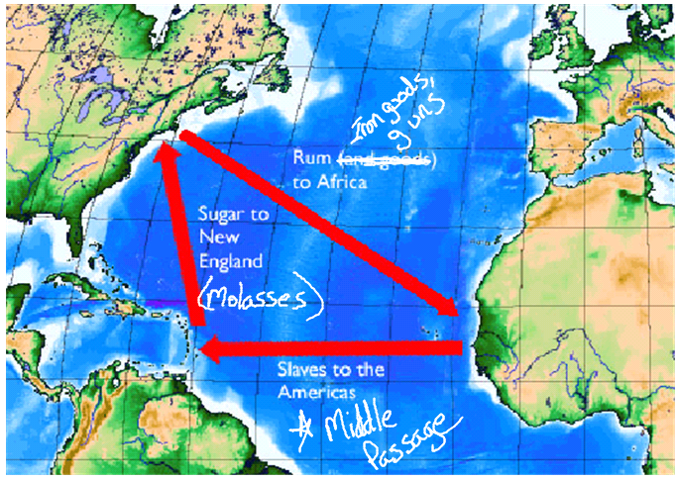
*This led to other businesses as well (making ropes, sails, and other shipping equipment)

Triangular Trade

New England Exports: ships, fish, wood products

Middle Colonies Exports: grains (corn, wheat)

Southern Colonies Exports: tobacco, rice, indigo

Lesson 3: Slavery in the Colonies

Vocab: plantations, slave codes, overseer
People: John Woolman, Robert Carter III

*Colonial farmers, merchants, lawyers, and shop owners bought slaves and indentured servants because colonial workers were scarce and expensive. (Slaves= cheap labor)

*Slaves in the North became servants or skilled workers. They worked side by side with their owner learning a trade.

*In the South, most slaves worked on large plantations.

*Slave owners enforced slave codes to control their slaves. Examples of these codes include: not allowed to practice their religion, learn to read, marry, or own property.

Life on a Plantation
Planter: had luxurious furniture and household items, was regarded as an important person when making economical decisions for the South.

Slave: long days doing backbreaking work, some slaves were skilled workers that made things for the plantation
*After working all day, slaves still had to do chores, tend their gardens, and prepare their supper.
*Most slaves came from Ghana and Nigeria in Africa*

*Their families gave slaves hope. On their day off of work, enslaved parents would try to visit their children who were often separated.

Climographs
- Climographs measure an area’s average monthly precipitation and temperature.

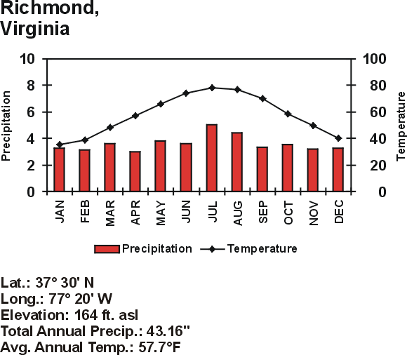

Lesson 4: The Colonial Way of Life

Vocab: frontier, almanac, backcountry
People: Benjamin Franklin

*By the mid 1700’s the English colonies were becoming a melting pot of people (lots of people from different areas/countries)

*At first people settled near the coast, but as coastal towns and cities became crowded people moved to the frontier.

*By 1775, Philadelphia was the largest city in the colonies, largely helped by Ben Franklin.

Benjamin Franklin
- He was a WRITER
  - He wrote funny stories and had them published in his brother’s newspaper under the name Mrs. Silence Dogood.
  - At the age of 23 he founded Pennsylvania’s first newspaper called the Pennsylvania Gazette.
  - He wrote an almanac called Poor Richard’s Almanac. The only book in the colonies to sell more copies was the Bible.

-He was a SCIENTIST and INVENTOR
  - He experimented with electricity (flying a kite with a key)
  - Invented- lightning rod, bifocal eyeglasses, Franklin stove

-Contributions for Philadelphia
  - Established the first volunteer fire company (Union Fire Company)
  - Opened the 1st public library
  - Started the first hospital
  - Served as Philadelphia’s official printer
  - Served as Postmaster General
  - Founded Pennsylvania’s first college (University of Pennsylvania), which was in Philadelphia
  - Helped start a school for African Americans in the late 1700’s.

*Colonial women often ran their household, raised the children, and helped with their husband’s business or family farm.

*As colonists moved to the backcountry, they moved onto land occupied by Native Americans resulting in both trade and fighting.

