Map Skills
Latitude: lines that run east to west on a map or globe

Longitude: lines that run north to south on a map or globe

Hemisphere: half of the globe

Equator: an imaginary line half way between the North and South Poles (0 degrees Latitude)

Prime Meridian: it’s the starting line for measuring longitude

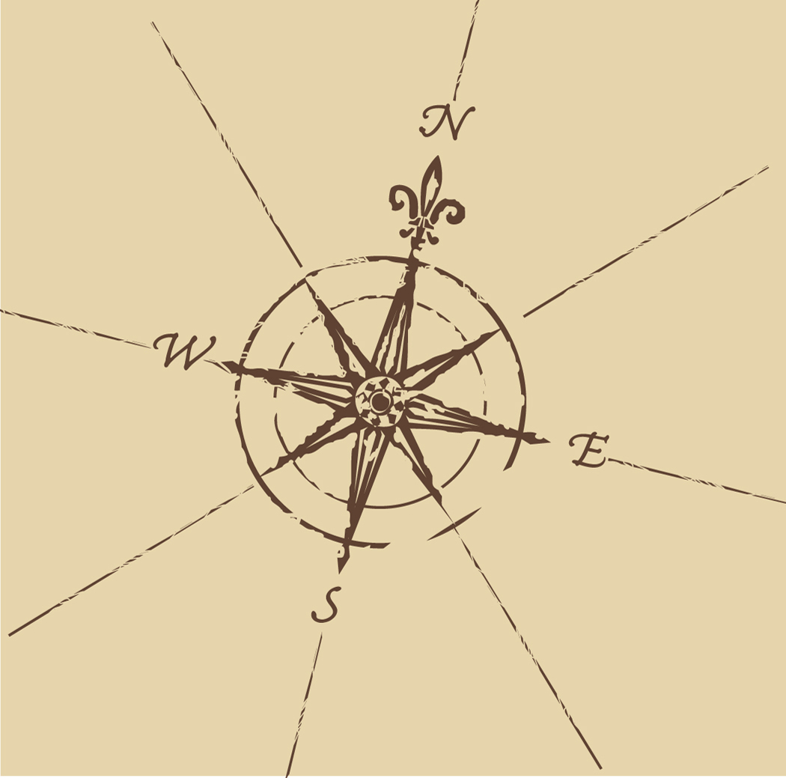
Compass rose: a picture that shows directions on a map

Scale: it explains how much smaller the map is compared to real life distances.

Ex. 1 inch on the map = 200 miles in real life

***The North Pole is located at 90 degrees North Latitude, The South Pole is located at 90 degrees South Latitude***

*** Be able to label all seven continents, the four oceans, and United States, Canada, Mexico, Iraq, Argentina, Russia, Great Britain, Spain, China ***

