Properties of Water Review

1. Write the chemical formula for water.

2. Draw a model of a water molecule. Label with the element symbol, charge, and place the electrons.

3. Explain what a solution is. Make sure to use the terms solute and solvent.

4. How is a water molecule like a magnet?

5. Which property cohesion or adhesion causes surface tension in water? Explain how this takes place.

6. Give an example of when you observed of surface tension. Give an example in nature.

7. Define cohesion in your own words. Give an example.

8. Define Adhesion in your own words. Give an Example.

9. Explain how water makes its way to the leaves in the tops of the tallest trees against the force of gravity. Name what the climbing of water is called and the two other properties that are responsible for making this possible.

10. Explain how Polar molecules can dissolves other polar molecules. You can use the example of H2O and NaCl (Table Salt)

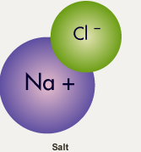

11. Why does ice float on liquid water?

12. How does ice help keep aquatic animal alive in the winters?

