**How to have access to Moodle as a Parent:**

1. Access Hamburg Area School District’s Moodle site: <http://moodle.hasdhawks.org/>
2. Click on the “Log-in” button on the top-right hand side of the screen

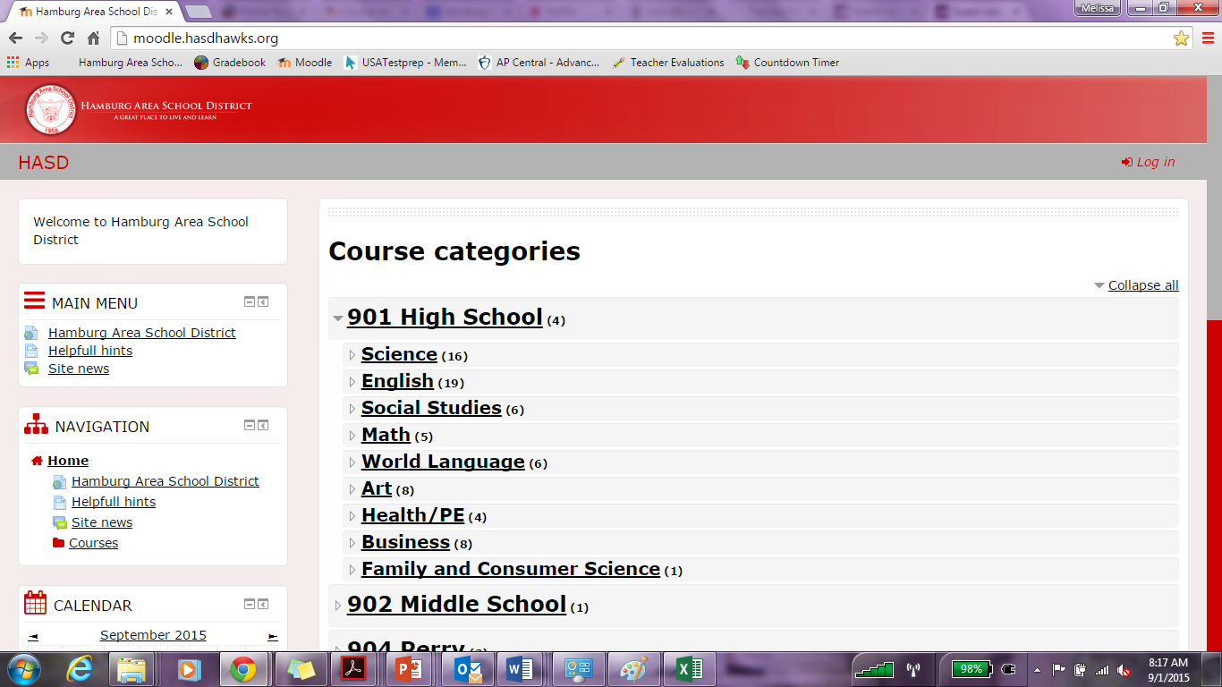

1. Click “Log-in as Guest” button at the bottom of the screen

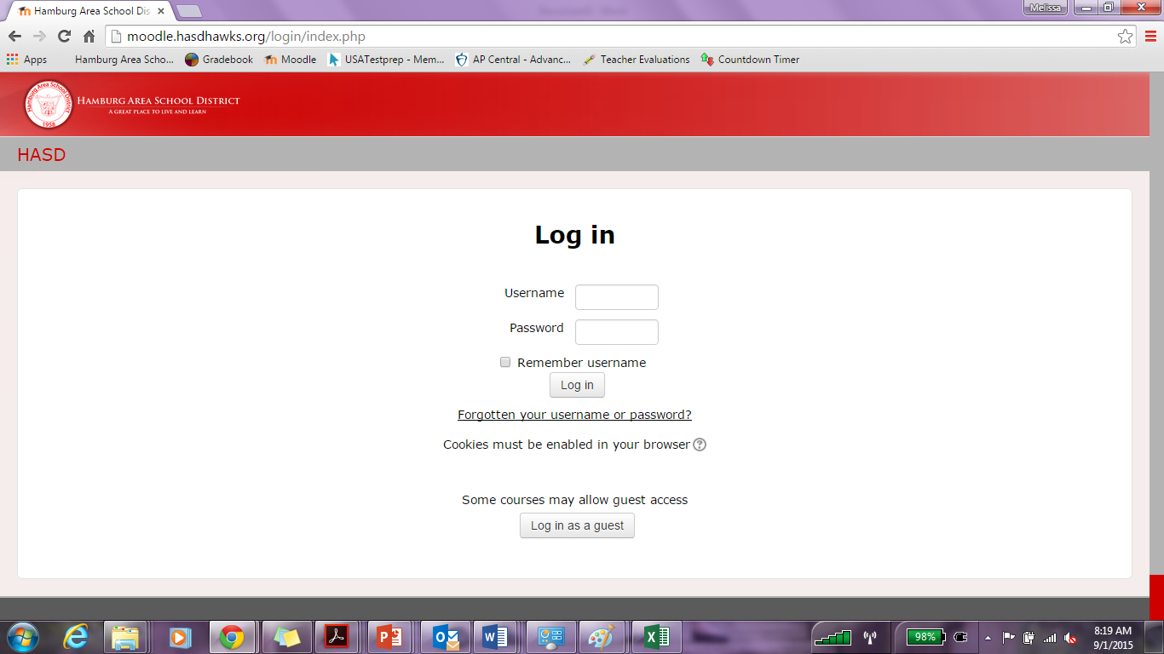

1. You will now be able to click on and enter any classes that are set-up to allow guest access.

**To access Mrs. Farina’s AP Biology Course:**

1. After you have logged in as a guest, click on “Science” under “Course Categories – High School”

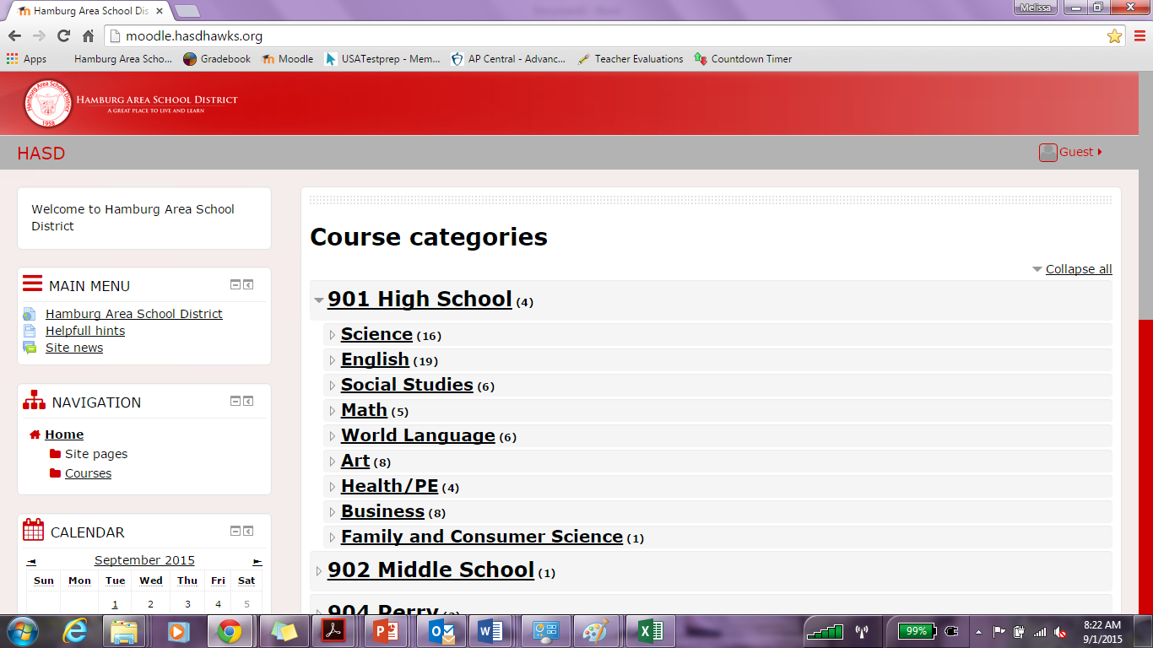

1. Click on “AP Biology – Farina”

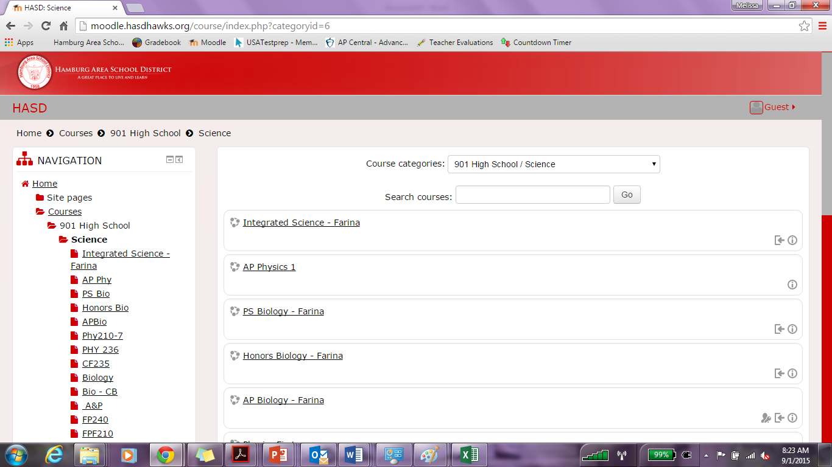

1. Here you will be promoted to enter a password and click submit.

AP Biology password 🡪 **APBiology2015**

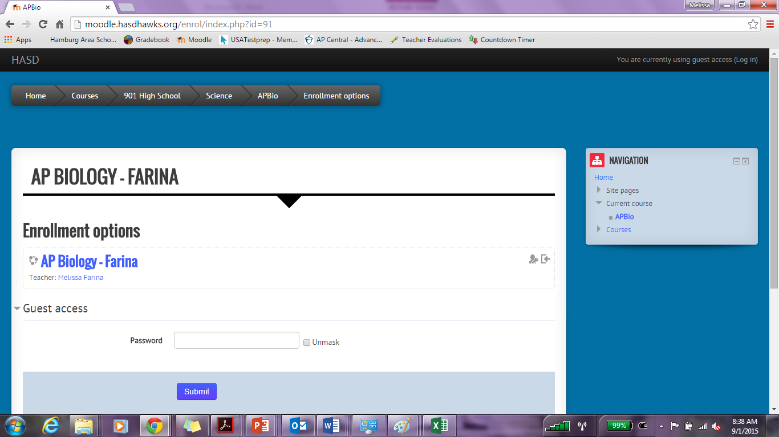

1. You should now have access to the AP Biology Moodle site. Here you will be able to access any documents posted, view the Google calendar, and have access to any links that are posted that are available for public access.

