**Keystone Exam Sample Questions**

**BIO.A.1 Basic Biological Principles**

1. Which characteristic is shared by all prokaryotes and eukaryotes?
2. ability to store heredity information
3. use of organelles to control cell processes
4. use of cellular respiration for energy release
5. ability to move in response to environmental stimuli
6. Living organisms can be classified as prokaryotes or eukaryotes. What two structures are common to both prokaryotic and eukaryotic cells?
7. cell wall and nucleus
8. cell wall and chloroplast
9. plasma membrane and nucleus
10. plasma membrane and cytoplasm
11. Which statement best describes a difference between prokaryotic and eukaryotic cells?
12. The presence of both DNA and ribosomes in prokaryotic cells indicates that they are more complex than eukaryotic cells.
13. The larger size of prokaryotic cells indicates that they are more complex that eukaryotic cells.
14. The presence of membrane-bound organelles in eukaryotic cells indicates that they are more complex than prokaryotic cells.
15. The larger size of eukaryotic cells indicates that they are more complex than prokaryotic cells.
16. Alveoli are microscopic air sacs in the lungs of mammals. Which statement best describes how the structure of the alveoli allows the lungs to function properly?
17. They increase the amount of energy transferred from the lungs to the blood.
18. They increase the flexibility of the lungs as they expand during inhalation.
19. They increase the volume of the lungs, allowing more oxygen to be inhaled.
20. They increase the surface area of the lungs, allowing efficient gas exchange.

5. **Prokaryotic cells are generally much smaller than eukaryotic cells.**

**Part A:** Identify a structural difference between prokaryotic and eukaryotic cells that is directly related to their difference in size.

**Part B:** Based on the structural difference between prokaryotic and eukaryotic cells, explain why prokaryotic cells can be much smaller than eukaryotic cells.

**Part C:** Describeone similaritybetween prokaryotic and eukaryotic cells that is independent of size.

**BIO.A.2 The Chemical Basis for Life**

6. Which statement **best** describes an effect of the low density of frozen water in a lake?

1. When water freezes, it contracts, decreasing the water level in a lake.
2. Water level in a lake freezes from the bottom up, killing most aquatic organisms.
3. When water in a lake freezes, it floats, providing insulation for organisms below.
4. Water removes thermal energy from the land around a lake, causing the lake to freeze.

7. Which statement correctly describes how carbon’s ability to form four bonds makes it uniquely suited to form macromolecules?

1. It forms short, simple carbon chains.
2. It forms large, complex, diverse molecules.
3. It forms covalent bonds with other carbon atoms.
4. It forms covalent bonds that can exist in a single plane.

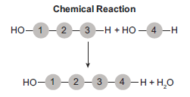8. The diagram shows a reaction that forms a polymer from two monomers. What is this type of reaction called?

1. glycolysis
2. hydrolysis
3. photosynthesis
4. dehydration synthesis

9. Carbohydrates and proteins are two types of macromolecules. What functional characteristic of proteins distinguishes them from carbohydrates?

1. large amounts of stored information
2. ability to catalyze biochemical reactions
3. efficient storage of usable chemical energy
4. tendency to make cell membranes hydrophobic

**Use the diagram to answer the question.**

10. The diagram models how a poison bonds to the active site of an enzyme. Which function is the enzyme **most likely** unable to perform because of the attachment of the poison molecule?

1. 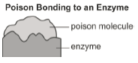the release of stored chemical energy
2. the donations of electrons to a substrate
3. the supply of activation energy for a reaction
4. the catalysis of a reaction with a substrate

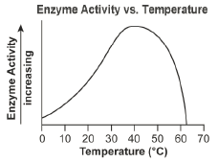**Use the diagram to answer the question below.**

11. The graph shows how the activity of an enzyme changes at different temperatures. Which statement **best** describes what happens to the enzyme when the temperature of the reaction increases to 63oC?

1. The enzyme is used up and the reaction stops.
2. The enzyme begins to decrease the rate of reaction.
3. The enzyme continues to increase the rate of reaction
4. The enzyme changes shape and can no longer speeds up the reaction.

12. Which statement **best** compares the energy of transformation of photosynthesis and cellular respiration?

1. Only photosynthesis uses oxygen to create energy.
2. Only photosynthesis causes an increase in kinetic energy.
3. Photosynthesis and cellular respiration both store energy in chemical bonds.
4. Photosynthesis and cellular respiration both require chemical energy to make food.

13. Substance A is converted to substance B in a metabolic reaction. Which statement **best** describes the role of an enzyme during this reaction?

1. It adjusts the pH of the reaction medium.
2. It provides energy to carry out the reaction.
3. It dissolves substance A in the reaction medium.
4. It speeds up the reaction without being consumed.

14. A scientist observes that, when the pH of the environment surrounding an enzyme is changed, the rate that the enzyme catalyzes a reaction greatly decreases. Which statement **best** describes how a change in pH can affect an enzyme?

1. A pH change can cause the enzyme to change its shape.
2. A pH change can remove energy necessary to activate an enzyme.
3. A pH change can add new molecules to the structure of the enzyme.
4. A pH change can cause an enzyme to react with a different substrate.

**15. Proteins are a major part of every living cell and have many different functions within each cell. Carbohydrates also perform numerous roles in living things.**

**Part A:** Describe the general composition of a protein molecule.

**Part B:** Describe how the structures of proteins differ from the structures of carbohydrates.

**Part C:** Describe how the functions of proteins differ from the structures of carbohydrates.

**BIO.A.3 Bioenergetics**

16. Substance A is converted to substance B in a metabolic reaction. Which statement **best** describes the role of an enzyme during a reaction?

1. It adjusts the pH of the reaction medium.
2. It provides energy to carry out the reaction.
3. It dissolves substance A in the reaction medium.
4. It speeds up the reaction without being consumed.

17. A scientist observes that, when the pH of the environment surrounding an enzyme has changed, the rate the enzyme catalyzes a reaction greatly decreases. Which statement **best** describes how a change in pH can affect an enzyme?

1. A pH change can cause the enzyme to change shape.
2. A pH change can remove energy necessary to activate the enzyme.
3. A pH change can add new molecules to the structure of the enzyme.
4. A pH change can cause an enzyme to react with a different substrate.

18. Using a microscope, a student observes a small, green organelle in a plant cell. Which energy transformation **most likely** occurs first within the observed organelle?

1. ATP to light
2. light to chemical
3. heat to electrical
4. chemical to chemical

19. Photosynthesis and cellular respiration are two major processes of carbon cycling in living organisms. Which statement correctly describes one similarity between photosynthesis and cellular respiration?

1. Both occur in plant and animal cells.
2. Both include reactions that transform energy.
3. Both convert light energy to chemical energy.
4. Both synthesize organic molecules as end products.

20. A protein in a cell membrane changed its shape to move sodium and potassium ions against their concentration gradients. Which molecule was **most likely** used by the protein as an energy source?

1. ATP
2. ADP
3. catalase
4. amylase

21. Which statement **best** compares the energy transformations of photosynthesis and cellular respiration?

1. Only photosynthesis can use oxygen to create energy.
2. Only photosynthesis causes an increase in kinetic energy.
3. Photosynthesis and cellular respiration both store energy in chemical bonds.
4. Photosynthesis and cellular respiration both require chemical energy to make food.

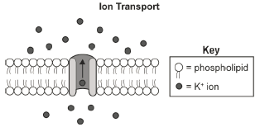**Use the diagram below to answer the question.**

22. The diagram shows the movement of ions against the concentration gradient to an area of higher concentration. Which molecule provides the energy needed for this movement?

1. ATP
2. mRNA
3. protein
4. lipid

**23. Use the diagrams below to answer the question.**

**Part A:**

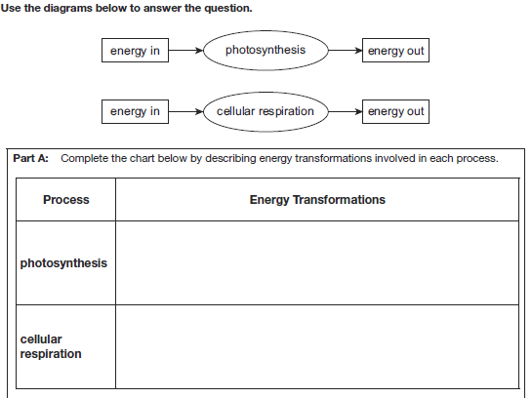

**Please refer above for the task explanation.**

**Part B:** Describe how energy transformations involved in photosynthesis are related to energy transformations involved in cellular respiration.

**BIO.A.4 Homeostasis and Transport**

24. Carbon dioxide and oxygen are molecules that can move freely across a plasma membrane. What determines the direction that carbon dioxide and oxygen molecules move?

1. orientation of cholesterol in the plasma membrane
2. concentration gradient across the plasma membrane
3. configuration of phospholipids in the plasma membrane
4. location of receptors on the surface of the plasma membrane.

25. A sodium-potassium pump within a cell membrane requires energy to move sodium and potassium ions into or out of the cell. The movement of glucose in or out of the cell does not require energy. Which statement best describes the movement of these materials across a cell membrane?

1. Sodium and potassium ions move by active transport, and glucose moves by osmosis.
2. Sodium and potassium ions move by active transport, glucose moves by facilitated diffusion.
3. Sodium and potassium ions move by facilitated diffusion, glucose moves by osmosis.
4. Sodium and potassium ions move by facilitated diffusion, glucose moves by active transport.

26. The rough endoplasmic reticulum and Golgi apparatus work together in eukaryotic cells. What is one way that the rough endoplasmic reticulum assists the Golgi apparatus?

1. It assembles nucleic acids from monomers.
2. It breaks down old, damaged macromolecules.
3. It packages new protein molecules into vesicles.
4. It determines which protein molecules to synthesize.

27. Which example is an activity that a fish **most likely** uses to maintain homeostasis within the body?

1. using camouflage to avoid predators
2. feeding at night to regulate body temperature
3. 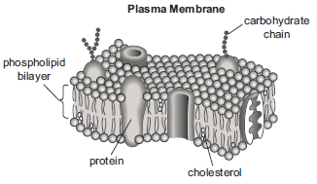moving to deeper water to regulate metabolic waste
4. exchanging gases through its gills to regulate oxygen levels

**Use the diagram to the right to answer the question.**

28. Which component of this membrane contains a hydrophobic region and acts as the primary barrier to **most** foreign substances?

1. protein
2. cholesterol
3. carbohydrate chain
4. phospholipid bilayer

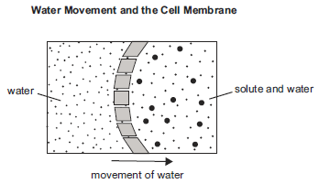**Use the diagram below to answer the question.**

29. The relative concentration of solute inside and outside the cell can cause water molecules to move across the membrane. Which phrase would be an alternate title to the diagram?

1. Exocytosis in a Cell
2. Active Transport in a Cell
3. Osmosis Across a Membrane
4. Facilitated Diffusion Across a Membrane

**Use the information below to answer the next two questions.**

**Chemical Discovery**

A scientist formed Chemical X in a laboratory. The material was then analyzed by other scientists.

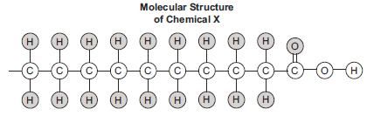

Analysis showed that the chemical was composed of long chains of repeated copies of CH2 molecules.

30. A researcher noticed that a similar CH2 molecular structure was also located in the plasma membrane of an animal cell. This CH2 molecular structure contained a negatively charged phosphate group. Which statement best describes the primary function of the CH2 and phosphate molecular structure located in the plasma membrane?

1. It contains the genetic information needed for protein production.
2. It catalyzes specific chemical reactions in the cytoplasm of the cell.
3. It stores the energy that a cell needs to perform various life processes.
4. It allows a cell to regulate the movement of materials into and out of the cell.

31. Which type of organic molecule was **most likely** formed by the scientist in the laboratory?

1. lipid
2. protein
3. nucleic acid
4. carbohydrate

32. Some animals can produce a potassium ion concentration inside their cells that is twenty times greater than that of their environment. The ion concentration gradient is maintained by the plasma membrane.

**Part A:** Identify the process in the cell membrane that produces this difference in concentration.

**Part B:** Explain the process that occurs as a cell produces the ion concentration gradient.

**Part C:** Compare the processes of potassium ion transport to another mechanism that moves material across the plasma membrane.

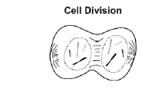**BIO.B.1 Cell Growth and Reproduction**

**Use the illustration to answer the question.**

33. Which phase **best** describes the phase of the cell cycle shown?

1. The cell is in prophase of mitosis because the number of chromosomes has doubled.
2. The cell is in prophase I of meiosis because the number of chromosomes has doubled.
3. The cell is in telophase of mitosis because the cell is separating and contains two copies of each chromosome.
4. The cell is in telophase of meiosis because the cell is separating and contains two copies of each chromosome.

34. Mitosis and meiosis are processes by which animal and plant cells divide. Which statement **best** describes the difference between mitosis and meiosis?

1. Meiosis is a multi-step process.
2. Mitosis occurs only in eukaryotic cells.
3. Meiosis is used in the repair of an organism.
4. Mitosis produces genetically identical daughter cells.

35. Which process helps to preserve the genetic information stored in DNA during DNA replication?

1. the replacement of the nitrogen base uracil
2. enzymes quickly linking nitrogen bases with hydrogen bonds
3. the synthesis of unique sugar and phosphate molecules for each nucleotide
4. nucleotides lining up along the template strand according to the base pairing rules

36. In a flowering plant species, red flower color is dominant over white flower color. What is the genotype of any red-flowering plant resulting from this species?

1. red and white alleles present on one chromosome
2. red and white alleles present on two chromosomes
3. a red allele present on both homologous chromosomes
4. A red allele present on at least one of the two homologous chromosomes.

**Use the diagram to answer the question.**

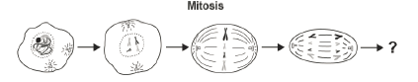

37. Which event **most likely** occurs next in mitosis?

1. The chromatin condenses.
2. The nuclear envelope dissolves.
3. The chromosomes double in number.
4. The cell membrane pinches inward to divide the cytoplasm.

**38. Pateau Syndrome can be a lethal genetic disorder in mammals, resulting for the chromosomes failing to separate during meiosis.**

**Part A:** Identify the step during the process of meiosis when chromosomes would **most likely** fail to separate.

**Part B:** Describe how chromosome separation in meiosis is different from chromosome separation in mitosis.

**Part C:** Compare the effects of a disorder caused by chromosomes failing to separate during meiosis, such as Pateau Syndrome, to the effects of chromosomes failing to separate during mitosis.

**BIO.B.2 Genetics**

**Use the table to answer the question.**

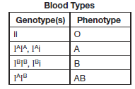

39. Blood type is inherited through multiple alleles, including IA, IB, and i. A child has type A blood. If the father has type AB blood, what are the possible phenotypes of the mother?

1. phenotypes O or A.
2. phenotypes A or B.
3. phenotypes A,B,AB.
4. phenotypes O, A, B, AB.

**Use the diagram to answer the question.**

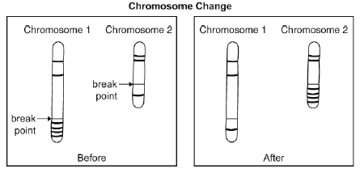

40. Which type of change in chromosome composition is illustrated in the diagram?

1. deletion
2. insertion
3. inversion
4. translocation

41. Which statement describes a cell process that is common to both eukaryotic and prokaryotic cells?

1. Both cell types carry out transcription in the nucleus.
2. Both cell types use ribosomes to carryout translation.
3. Both cell types assemble amino acids to carry out transcription.
4. Both cell types carry out translation in the endoplasmic reticulum.

42. The endoplasmic reticulum is a network of membranes within the cell, and is often classified as rough or smooth, depending on whether there are ribosomes on its surface. Which statement **best**

describes the role of rough endoplasmic reticulum in the cell?

1. It stores all proteins for later use.
2. It provides an attachment site for larger organelles.
3. It aids in the production of membrane and secretory proteins.
4. It stores amino acids required for the production of all proteins.

43. A genetic mutation resulted in a change in the sequence of amino acids of a protein, but the function of the protein was not changed. Which statement best describes the genetic mutation?

1. It was a silent mutation that caused a change in the DNA of the organism.
2. It was a silent mutation that caused a change in the phenotype of the organism.
3. It was a nonsense mutation that caused a change in the DNA of the organism.
4. It was a nonsense mutation that caused a change in the phenotype of the organism.

44. Genetic engineering has led to genetically modified plants that resist insect pests and bacterial and fungal infections. Which outcome would most likely be a reason why some scientists recommend caution in planting genetically modified plants?

1. unplanned ecosystem interactions
2. reduced pesticide and herbicide use
3. improved agricultural yield and profit
4. increased genetic variation and diversity

45. A scientist observes that a certain trait is determined by a single allele. An organism inherited one version of the trait from one parent and another version from the other parent. Both versions of the trait are expressed in the phenotype of the offspring. Which pattern of inheritance **best** classifies the observed trait?

1. dominance
2. sex-linkage
3. co-dominance
4. incomplete dominance

46. The bacterium *Acetobacter aceti* is found in acidic environments and has an acetic cytoplasm. For this reason, most of its proteins are able to function in acidic conditions. This property distinguishes *Acetobacter aceti*  from those of most other organisms. What characteristic does *Acetobacter aceti*  **most likely** share with other organisms?

1. the method that the organism uses to reproduce itself
2. the physical and chemical responses to environmental changes
3. the type of organelle used to produce energy for cellular functions
4. the process used to form proteins by transcription and translation

47. A mutation occurs at the midpoint of a gene, altering all amino acids encoded after the point of mutation. Which mutation could have produced this change?

1. deletion of two nucleotides
2. deletion of three nucleotides
3. insertion of six nucleotides
4. insertion of twelve nucleotides

48. A cattle farmer genetically crosses a cow (female) with a white coat with a bull (male) with a red coat. The resulting calf (offspring) is a roan, which means there are red and white hairs intermixed in the coat of the calf. The genes for coat color in cattle are co-dominant.

**Part A:** Although a farm has cattle in all three colors, the farmer prefers roan cattle over red or white cattle. Use the Punett square to show a cross that would produce only roan offspring.

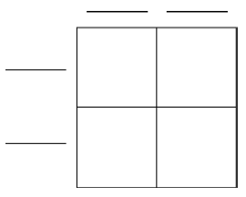

**Part B:** Explain how a roan calf results from one white and one red-coated parent. In your explanation, use letters to represent genes. Be sure to indicate what colors the letters represent.

**Part C:** Predict the possible genotypes and phenotypes of the offspring produced from two roan cattle.

**BIO.B.3 Theory of Evolution**

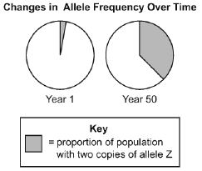**Use the circle graphs to answer the question.**

49. The graphs illustrate change in a lizard population over time. Which process **most likely** led to the change in the lizard population?

1. natural selection acting on a harmful trait
2. natural selection acting on a beneficial trait
3. natural selection acting on a dominant trait
4. natural selection acting on a recessive trait

50. In North America, the eastern spotted skunk mates in late winter, and the western spotted skunk mates in late summer. Even though their geographic ranges overlap, the species do not mate with each other. What **most likely** prevents these two species from interbreeding?

1. habitat isolation
2. gametic isolation
3. geographic isolation
4. reproductive isolation

51. A mutation occurs in the genes that coat for coat color in deer. Which change will **most likely** result from this mutation?

1. a change in the selection pressures acting on coat color
2. a change in the coat-color genes of deer predator species
3. an increase in coat-color diversity in the population
4. an increase in the number of genes for coat color in the population.

52. The frequency of an allele in the fly population changes from 89% to 20% after three generations. Which other events **most likely** occurred during the same period of time?

1. an environmental change and a fly population increase
2. an environmental change and a fly population decrease
3. interbreeding of flies with an invasive species and fly population speciation
4. interbreeding of flies with an established local species and fly population speciation

**Use the graph below to answer the question.**

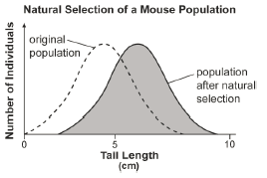

53. Tail length in mice varies within a population. Scientists observed a change in the distribution of tail lengths in a mouse population over time. At the genetic level, what has **most likely** happened to the allele for the shortest tail lengths?

1. The allele changed from being dominant to being recessive.
2. The allele changed from being autosomal to being sex-linked.
3. The allele became less frequent that the alleles for longer tail lengths.
4. The allele began to code for long tail lengths instead of the shortest ones.

**Use the table below to answer the question.**

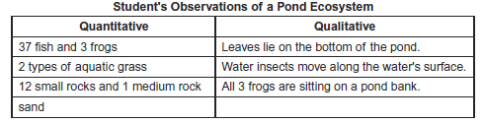

54. A group of students measured a ten-square-meter section of a pond ecosystem and recorded observations. Which statement is a testable hypothesis?

1. The frogs living in the pond represent a population.
2. Water is an abiotic component in the pond ecosystem.
3. If the fish are given more food, then they will be happier.
4. If the frogs are startled, then they will jump into the water.

**Use the illustration to answer the question.**

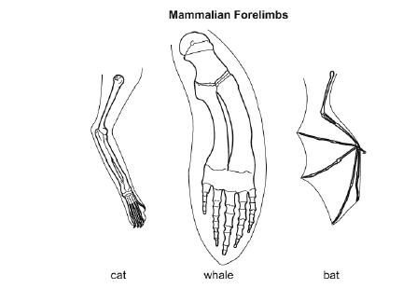

55. The skeletons of mammalian forelimbs represent variations of a structure that was present in their common ancestor. What has **most likely** caused the variation in forelimbs?

1. changes in muscle structure
2. changes in genetic code
3. trait formation due to behavior
4. development of vestigial structures

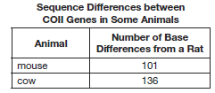**Use the table to answer the question.**

**56. The gene COII is in the genome of many organisms. A comparison of the number of base differences between the COII gene in a rat and that of two other animals is shown.**

**Part A:** Based on the data, describe the possible evolutionary relationship between rats, mice and cows.

**Part B:** Describe how different organisms having a common gene such as COII support the theory of evolution.

**Part C:** The COII gene of a monkey has 203 base differences from the same gene is a rat and 210 base differences from the same gene in a mouse. Compare the evolutionary relationships between the monkey, rat, and the mouse.

**BIO.B.4 Ecology**

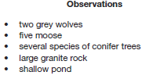**Use the list to answer the question.**

57. A student wrote several observations in a field notebook. Which term **best** classifies all of the student’s observations?

1. population
2. food chain
3. ecosystem
4. community

58. A researcher observing an ecosystem describes the amount of sunlight, precipitation, and type of soil present. Which factors in the researcher **most likely** describing?

1. biotic factors in a forest
2. biotic factors in a tundra
3. abiotic factors in a prairie
4. abiotic factors in an ocean

**Use the diagram to answer the question.**

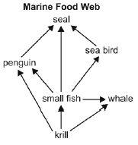

59. Which sequence correctly describes the flow of energy between organisms in a marine food web?

1. from seals to penguins to krill
2. from whales to krill to small fish
3. from sea birds to seals to penguins
4. from small fish to penguins to seals

60. A species of snapping turtles has a tongue that resembles a worm. The tongue is used to attract small fish. Which **best** describes the interaction between the fish and the snapping turtle?

1. predation
2. symbiosis
3. parasitism
4. competition

61. Which statement correctly describes how nitrogen in the soil returns to the atmosphere?

1. Soil bacteria convert nitrates into nitrogen gas.
2. Decomposers directly convert ammonium into nitrogen gas.
3. Plants assimilate nitrites and convert them into nitrogen gas.
4. Nitrogen-fixing bacteria in plant roots convert nitrates into nitrogen gas.

62. Agricultural runoff can carry fertilizers into lakes and systems. This runoff can cause algae populations to greatly increase. Which effect does this change in the algae population sizes **most likely** have on affected lakes and streams?

1. an increase in water level
2. an increase in water clarity
3. a reduction in dissolved oxygen needed by fish and shellfish
4. a reduction in temperature variations near the water’s surface.

63. A farmer observed that an increase in the field’s soil nitrogen content was followed by an increase in producer productivity. What does this observation **most likely** indicate about the relationship between nitrogen and the producers in the field?

1. Nitrogen was a biotic factor.
2. Nitrogen was a limiting factor.
3. Nitrogen became a surplus resource.
4. Nitrogen became a selection pressure.

64. Scientists observed that the population of top-level consumers in a particular ecosystem was rapidly decreasing. Further studies revealed that there was also a decline in producer productivity. Which other changes did the scientists **most likely** observe in the ecosystem?

1. increased producer diversity
2. decreased population size at all levels
3. decreased primary consumer populations only
4. increased primary and secondary consumer diversity

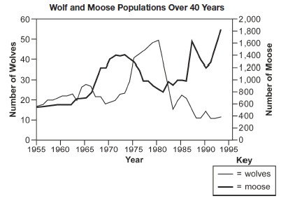**65. Use the graph to answer the question.**

Isle Royale is located in Lake Superior. Isle Royale is home to populations of wolves and moose. The interactions between the wolves and moose, as well as the individual population sizes, have been studied since 1958. The graph shows the population sizes over time for both wolves and moose.

**Part A:** Describe one limiting factor for the moose population.

**Part B:** Explain one likely reason why the wolf population rapidly increased between 1975 and 1980.

**Part C:** Predict what will happen to the moose population’s size after 1994 by describing the shape of the curve. In your answer, be sure to explain the reasoning behind your position.