The following types of sneakers are ***ACCEPTABLE*** footwear for Physical Education Class…

[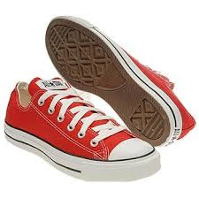](http://www.google.com/imgres?imgurl=http://media.nj.com/indulge/photo/back-to-school-shoes-1-25f84fd71a2acc61.jpg&imgrefurl=http://www.nj.com/indulge/index.ssf/2012/08/famous_footwear_offers_back_to.html&h=350&w=350&tbnid=B5of4GBWMQ9IIM:&zoom=1&docid=nOSJZlAPNdlxVM&hl=en&ei=qFZ6U9e5M4WuyAT11YD4Dg&tbm=isch&ved=0CIwBEDMoHTAd&iact=rc&uact=3&dur=1357&page=2&start=10&ndsp=22)[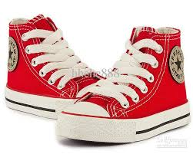](http://www.google.com/imgres?imgurl=http://image.dhgate.com/albu_354653012_00-1.0x0/best-selling-size-23-35-children-canvas-shoes.jpg&imgrefurl=http://www.dhgate.com/store/product/best-selling-size-23-35-children-canvas-shoes/160651114.html&h=554&w=693&tbnid=phyJcBlsRx1wHM:&zoom=1&docid=X-uX561zWg4-cM&hl=en&ei=qFZ6U9e5M4WuyAT11YD4Dg&tbm=isch&ved=0CKIBEDMoMzAz&iact=rc&uact=3&dur=561&page=6&start=46&ndsp=9) [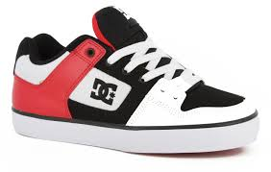](http://www.google.com/imgres?imgurl=http://www.tactics.com/a/5xvu/9/dc-pure-skate-shoes-white-black-athletic-red.jpg&imgrefurl=http://www.tactics.com/dc/pure-skate-shoes/white-black-athletic-red&h=951&w=1500&tbnid=TrQdFrgr5AkOgM:&zoom=1&docid=pvSk2-YFAyfmDM&hl=en&ei=qFZ6U9e5M4WuyAT11YD4Dg&tbm=isch&ved=0CKgBEDMoOTA5&iact=rc&uact=3&dur=407&page=7&start=55&ndsp=9) [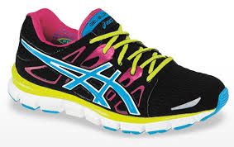](http://www.google.com/imgres?imgurl=http://g-ecx.images-amazon.com/images/G/01/img11/shoes/a_plus_detail/c26-B006H1CJY6-1-l.jpg&imgrefurl=http://www.amazon.com/ASICS-Womens-GEL-Blur33-Running-Shoe/dp/B006H1CJY6&h=350&w=554&tbnid=o6zBjRvwq7zTbM:&zoom=1&docid=wTHVyWQRX4QubM&hl=en&ei=qFZ6U9e5M4WuyAT11YD4Dg&tbm=isch&ved=0CKYBEDMoNzA3&iact=rc&uact=3&dur=718&page=7&start=55&ndsp=9) [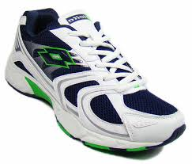](http://www.google.com/imgres?imgurl=http://static2.shop.indiatimes.com/images/products/additional/original/B1939005_View_1/fashion/sports/lotto-siato-white-men-sports-shoes-siato.jpg&imgrefurl=http://shopping.indiatimes.com/fashion/sports/lotto-siato-white-men-sports-shoes-siato/41800/p_B1939005&h=1024&w=1200&tbnid=cYqCNTkuLwHkkM:&zoom=1&docid=uBG1gnn_qUXcKM&hl=en&ei=z1d6U87ZPIKeyATAiIIQ&tbm=isch&ved=0CB0QMygVMBU4ZA&iact=rc&uact=3&dur=4000&page=13&start=113&ndsp=9) [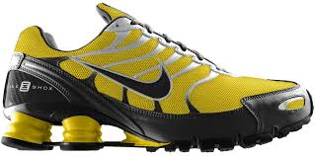](http://www.google.com/imgres?imgurl=http://eyecatchy.net/wp-content/uploads/2013/12/running-shoes-design.jpeg&imgrefurl=http://eyecatchy.net/running-shoes-basic-knowledges/best-running-shoes-ever/&h=795&w=1600&tbnid=dGHRgiNhBJyDHM:&zoom=1&docid=XyTLy7i_6NPFgM&hl=en&ei=jVl6U6bzKsunyASihoGgBA&tbm=isch&ved=0CGkQMyhhMGE4rAI&iact=rc&uact=3&dur=1076&page=40&start=392&ndsp=6)

[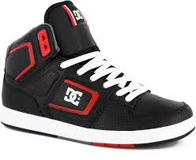](http://www.google.com/imgres?imgurl=http://2hdwallpapers.com/wp-content/uploads/2014/04/dc-factory-lite-hi-skate-shoes-black-white-true-red.jpg&imgrefurl=http://2hdwallpapers.com/shoes/&h=1230&w=1500&tbnid=JKNLmtSP-A9CuM:&zoom=1&docid=EoAoup8ce9Xf8M&hl=en&ei=fCqNU8fCLoGlyASSs4Bg&tbm=isch&ved=0CAgQMygAMAA4kAM&iact=rc&uact=3&dur=603&page=19&start=389&ndsp=22) [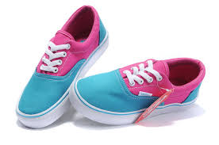](http://www.google.com/imgres?imgurl=http://fashnfun.com/wp-content/uploads/2013/02/Vans-Canvas-Pink-Blue-Shoes-For-Women.jpg&imgrefurl=http://bindas-smile.blogspot.com/2013/03/shoes-for-girl.html&h=464&w=700&tbnid=ajZuoTNstB6C5M:&zoom=1&docid=424mNZpJAjtcKM&hl=en&ei=wP7xU9jKCpWeyASYmIDIAg&tbm=isch&ved=0CC8QMygnMCc4yAE&iact=rc&uact=3&dur=1345&page=11&start=232&ndsp=24)[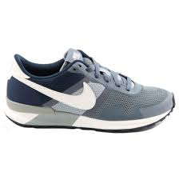](http://www.google.com/imgres?imgurl=http://www.shoebedo.de/images/produkte/i28/2808-Nike-Sneaker-Air-Pegasus-83-30-Armory-Slate-Sl-Slvr.jpg&imgrefurl=http://galleryhip.com/nike-sneakers.html&h=1000&w=999&tbnid=ySAGSxUaOM_jvM:&zoom=1&docid=xxfl5VFZJo5UJM&hl=en&ei=ZDCNU-O1OYGPyASrtIKAAg&tbm=isch&ved=0CGoQMyhiMGI4kAM&iact=rc&uact=3&dur=418&page=22&start=477&ndsp=23)[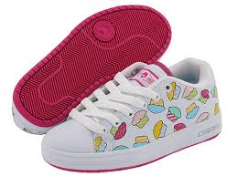](http://www.google.com/imgres?imgurl=http://www.infobarrel.com/media/image/12958.jpg&imgrefurl=http://www.infobarrel.com/Media/Girl's_Osiris_Shoes&h=360&w=480&tbnid=0TdfAiojW7L-pM:&zoom=1&docid=8vHGPFdcOxRZhM&hl=en&ei=F_3xU_WiE4aBygTxqIFI&tbm=isch&ved=0CAgQMygAMAA4ZA&iact=rc&uact=3&dur=508&page=5&start=86&ndsp=24)[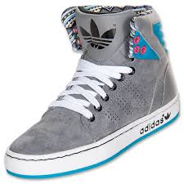](http://www.google.com/imgres?imgurl=http://infashionshoe.com/wp-content/uploads/2014/08/adidas-shoes-for-girlsgirls-gradeschool-adidas-originals-adihigh-ext-casual-shoes-wso1emc3.jpg&imgrefurl=http://infashionshoe.com/adidas-shoes-for-girls-2014/&h=510&w=510&tbnid=bmUruLE3YSqUwM:&zoom=1&docid=HuVC7TmU4YSFGM&hl=en&ei=mvvxU6aDI9ivyATtwIDAAg&tbm=isch&ved=0CH4QMyhBMEE&iact=rc&uact=3&dur=826&page=4&start=62&ndsp=24) [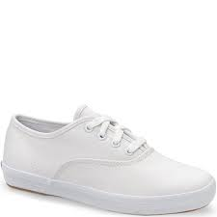](http://www.google.com/imgres?imgurl=http://cdn3.volusion.com/hmoc7.c26yf/v/vspfiles/photos/205KT31577F-2.jpg?1377258265&imgrefurl=http://www.tentalltrees.com/kids-keds-white-sneakers-p/205kt31577f.htm&h=1200&w=1200&tbnid=6wKd0zCd39CYnM:&zoom=1&docid=s5hzdTGR0LUgyM&hl=en&ei=qejyU73AOoaUyATf9ILIDw&tbm=isch&ved=0CGcQMyhfMF84ZA&iact=rc&uact=3&dur=1089&page=10&start=193&ndsp=24)[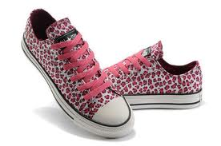](http://www.google.com/imgres?imgurl=http://www.cheapcartoonshoes.com/images/Leopard%20Shoes/Leopard-Converse-All-Star-Shoes-For-Girls-Low-Purple_2.jpg&imgrefurl=http://www.cheapcartoonshoes.com/leopard-converse-all-star-shoes-for-girls-low-purple-p-9952&h=297&w=448&tbnid=mZpUsvUUto2PsM:&zoom=1&docid=AwQe2mGH9l-LBM&hl=en&ei=mvvxU6aDI9ivyATtwIDAAg&tbm=isch&ved=0CGcQMygqMCo&iact=rc&uact=3&dur=1114&page=3&start=38&ndsp=24)[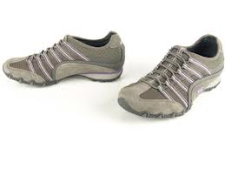](http://www.google.com/imgres?imgurl=http://imgc.classistatic.com/cps/blnc/121210/090r1/3796h9m_20.jpeg&imgrefurl=http://funny-pictures.picphotos.net/sketches-footwear-online-pictures/skechersshoesoutletsale.com*1030-194-thickbox*where-skechers-sandals-gold-skechers-womens-work-shoes.jpg/&h=600&w=800&tbnid=NNI_KEjFW0AZfM:&zoom=1&docid=w8sKBCrhlMN27M&hl=en&ei=RTKNU6OxG8muyASIyoHQBg&tbm=isch&ved=0CDgQMygwMDA4rAI&iact=rc&uact=3&dur=2219&page=18&start=346&ndsp=22)[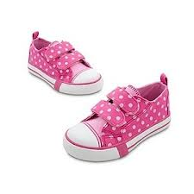](http://www.google.com/imgres?imgurl=http://www.polyvore.com/cgi/img-thing?.out=jpg&size=l&tid=61035835&imgrefurl=http://www.polyvore.com/polka_dot_minnie_mouse_sneakers/thing?id=61035835&h=300&w=300&tbnid=7txCTo0u2Vv55M:&zoom=1&docid=ZRTTeMOkhjfy_M&hl=en&ei=l-jyU4TkNIuOyASI2YDwAg&tbm=isch&ved=0CKABEDMoYzBj&iact=rc&uact=3&dur=739&page=6&start=96&ndsp=25)[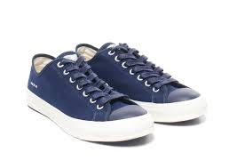](http://www.google.com/imgres?imgurl=http://www.selectism.com/files/2013/05/wtaps-canvas-sneakers-02.jpg&imgrefurl=http://www.selectism.com/2013/05/24/wtaps-canvas-sneakers-in-four-colors/&h=876&w=1236&tbnid=0l_1ypzsLWiXEM:&zoom=1&docid=P4mAc99f_WKcxM&hl=en&ei=rS-NU7SFJ9WpyATVhoKIDw&tbm=isch&ved=0CF4QMygYMBg&iact=rc&uact=3&dur=1829&page=2&start=11&ndsp=23)[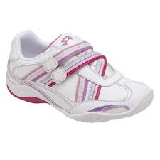](http://www.google.com/imgres?imgurl=http://www.goodhousekeeping.com/cm/goodhousekeeping/images/Zd/stride-rite-kenzie-girls-0809-lg.jpg&imgrefurl=http://www.goodhousekeeping.com/product-reviews/childrens-products/kids-sneakers-reviews/best-sneakers-for-girls&h=325&w=325&tbnid=RxGbMW7OvGgPhM:&zoom=1&docid=kjjT2I9Ok3Rc2M&hl=en&ei=l-jyU4TkNIuOyASI2YDwAg&tbm=isch&ved=0CH0QMyhAMEA&iact=rc&uact=3&dur=323&page=4&start=54&ndsp=20)[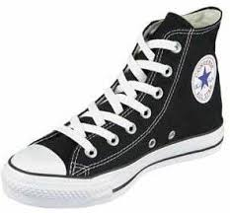](http://www.google.com/imgres?imgurl=http://2.bp.blogspot.com/-JYHrl6DGOJo/TbHl8jQ3MlI/AAAAAAAADrI/yMLIdMQUfFM/s320/popular-converse-shoes-2.jpg&imgrefurl=http://buyonline-fashion.blogspot.com/2011/05/converse-shoes-for-girls-2011_24.html&h=275&w=297&tbnid=azsqLN-_zAJTqM:&zoom=1&docid=bbBlnpF0lmQOPM&hl=en&ei=F_3xU_WiE4aBygTxqIFI&tbm=isch&ved=0CDQQMygsMCw4ZA&iact=rc&uact=3&dur=514&page=7&start=135&ndsp=24)

The following types of footwear are ***NOT ACCEPTABLE*** for Physical Education Class….

[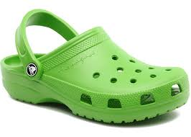](http://www.google.com/imgres?imgurl=http://i.telegraph.co.uk/multimedia/archive/02782/Crocs_2782707a.jpg&imgrefurl=http://fashion.telegraph.co.uk/article/TMG10553515/Crocs-shoes-high-fashion-turnaround.html&h=380&w=532&tbnid=K2WHD-aZmBrT6M:&zoom=1&docid=7n6TtRgZP2NbsM&hl=en&ei=ejKNU8G0OoWyyATl1oA4&tbm=isch&ved=0CGsQMygiMCI&iact=rc&uact=3&dur=427&page=3&start=30&ndsp=20)[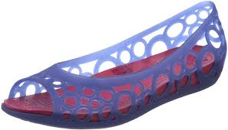](http://www.google.com/imgres?imgurl=http://1.bp.blogspot.com/-EXFqqNgd4ic/T_sKhY_zJqI/AAAAAAAACA0/H3AYH5uacKU/s1600/Crocs+Women's+Adrina+Flat+01.jpg&imgrefurl=http://crocs-shoes-at.blogspot.com/&h=860&w=1500&tbnid=iA65vGCJlurG0M:&zoom=1&docid=OkucHclbK21FYM&hl=en&ei=ejKNU8G0OoWyyATl1oA4&tbm=isch&ved=0CJABEDMoRzBH&iact=rc&uact=3&dur=589&page=5&start=71&ndsp=16)[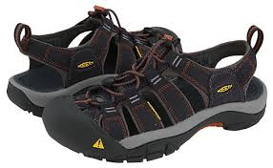](http://www.google.com/imgres?imgurl=http://0.tqn.com/d/shoes/1/0/q/t/1/mens-sandals-2013.jpg&imgrefurl=http://shoes.about.com/od/man_men_mens_shoes/tp/mens_sandals.htm&h=305&w=493&tbnid=qma-Ao1fqt8y5M:&zoom=1&docid=3mRKr1Cb2LMd4M&hl=en&ei=1DONU96LLY-QyATx3YCAAg&tbm=isch&ved=0CFEQMyhJMEk4ZA&iact=rc&uact=3&dur=801&page=9&start=162&ndsp=23)[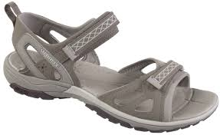](http://www.google.com/imgres?imgurl=http://www.oershang.com/images/3/J88960.jpg&imgrefurl=http://www.oershang.com/merrell-womens-avian-light-strap-sandals-brindle-p-2021/&h=737&w=1200&tbnid=21zcNDa30I7gUM:&zoom=1&docid=G1ZpRO2xw7JdEM&hl=en&ei=1DONU96LLY-QyATx3YCAAg&tbm=isch&ved=0CCwQMygkMCQ4ZA&iact=rc&uact=3&dur=499&page=7&start=120&ndsp=18)[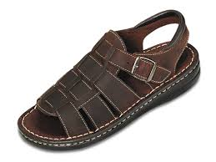](http://www.google.com/imgres?imgurl=http://cwgala.files.wordpress.com/2010/02/man-sandals.jpg&imgrefurl=http://cwgala.wordpress.com/2010/02/04/guys-dont-do-this/&h=900&w=1200&tbnid=FprgeNm86XLHLM:&zoom=1&docid=d1bnv4qlP5Uk2M&hl=en&ei=SjSNU73WEMOyyASzuYDwBQ&tbm=isch&ved=0CBIQMygKMAo4rAI&iact=rc&uact=3&dur=963&page=15&start=296&ndsp=23)[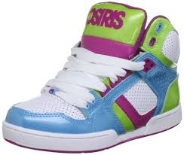](http://www.google.com/imgres?imgurl=http://galleryplus.ebayimg.com/ws/web/300882337759_1_0_1/1000x1000.jpg&imgrefurl=http://www.ebay.com/sch/Girls-Shoes-/57974/i.html?_dcat=57974&Brand=Osiris&US%20Shoe%20Size%20(Youth)=12&h=846&w=1000&tbnid=4qwD7wU66ZEM6M:&zoom=1&docid=QmElYKLwPxH74M&hl=en&ei=li6NU8U_g5nIBKiSgqgM&tbm=isch&ved=0CJsBEDMoXjBe&iact=rc&uact=3&dur=591&page=5&start=78&ndsp=26)[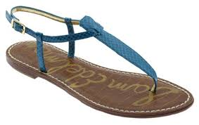](http://www.google.com/imgres?imgurl=http://www.dbeststyle.com/wp-content/uploads/2013/12/simple-sandal-5.jpg&imgrefurl=http://www.dbeststyle.com/shoes/flat-sandals.html&h=379&w=600&tbnid=PTHprcKwFcMC7M:&zoom=1&docid=A_HrfkiKembbYM&hl=en&ei=SjSNU73WEMOyyASzuYDwBQ&tbm=isch&ved=0CCMQMygbMBs4rAI&iact=rc&uact=3&dur=447&page=16&start=319&ndsp=19)

[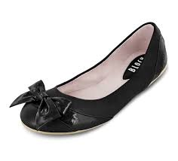](http://www.google.com/imgres?imgurl=http://boutiquebaglady.com/wp-content/uploads/2014/05/black-shoes-for-girls-flatsflats-shoes-for-girls-find-the-latest-news---quoteko-ubwnqnzo.jpg&imgrefurl=http://boutiquebaglady.com/flats-shoes-for-girls-find-the-latest-news-quoteko.html&h=760&w=840&tbnid=DfBxzHiJ7KzpGM:&zoom=1&docid=vXqZIBPna6ZdGM&hl=en&ei=mvvxU6aDI9ivyATtwIDAAg&tbm=isch&ved=0CJwBEDMoXzBf&iact=rc&uact=3&dur=4052&page=5&start=86&ndsp=24)[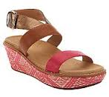](http://www.google.com/imgres?imgurl=http://images.qvc.com/is/image/a/72/a239872.001?$usmedium$&imgrefurl=http://www.qvc.com/Orthaheel.content.html&h=164&w=184&tbnid=hmwlVvaFm0zP8M:&zoom=1&docid=6NDKt-g2SpiByM&itg=1&hl=en&ei=FTWNU4vPAYaOyATC1oJg&tbm=isch&ved=0CDsQMygzMDM4hAc&iact=rc&uact=3&dur=422&page=43&start=929&ndsp=25)[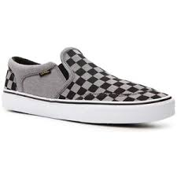](http://www.google.com/imgres?imgurl=http://ak2.polyvoreimg.com/cgi/img-thing/size/l/tid/109991650.jpg&imgrefurl=http://www.polyvore.com/slip_on_sneakers/shop?query=slip+on+sneakers&h=300&w=300&tbnid=XtsbPYRX7RYtpM:&zoom=1&docid=Yp3kXm6fZ0KOHM&itg=1&hl=en&ei=EzGNU8bzNoO0yASZjYLQBw&tbm=isch&ved=0CAkQMygBMAE4hAc&iact=rc&uact=3&dur=768&page=40&start=887&ndsp=26)[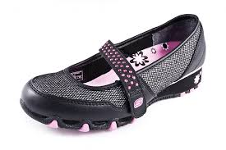](http://www.google.com/imgres?imgurl=http://www.touristinformationcentres.net/webshop/images/webshop/224/product/large/Sparkle-Babies.jpg&imgrefurl=http://www.shooligansshoes.co.uk/p37691/Skechers-Sparkle-Babies--Girls-Shoe/c0-9517-9519&h=682&w=1024&tbnid=Vb14zEMi71SABM:&zoom=1&docid=oC-06fsEb3CBsM&hl=en&ei=mTGNU5qrM4WuyASW5YHABQ&tbm=isch&ved=0CCIQMygaMBo4ZA&iact=rc&uact=3&dur=397&page=7&start=121&ndsp=23)[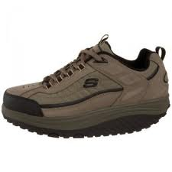](http://www.google.com/imgres?imgurl=http://www.resourcesforlife.com/wp/wp-content/uploads/2010/03/20100319fr-sketchers-shape-up-shoes-review-comparison-sale-300x300.jpg&imgrefurl=http://www.resourcesforlife.com/docs/item2551&h=300&w=300&tbnid=XzyaQJbBjSbfmM:&zoom=1&docid=7wFtJYUCT4xJqM&hl=en&ei=WjGNU7qLL4y2yATsgoGQDw&tbm=isch&ved=0CHAQMygnMCc&iact=rc&uact=3&dur=627&page=3&start=30&ndsp=24)[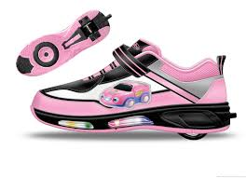](http://www.google.com/imgres?imgurl=http://www.evolution-shoes.com/uploadfile/product/roller-shoes/Roller-Shoes-Kids-18-1273284409-0.jpg&imgrefurl=http://www.evolution-shoes.com/Roller-Shoes-Kids-18-44.html&h=1283&w=1772&tbnid=F9yJMubzLaVUuM:&zoom=1&docid=TkpPzpFQ3J5NSM&hl=en&ei=a1h6U73tN4utyASljIDQAg&tbm=isch&ved=0CGgQMyhgMGA4ZA&iact=rc&uact=3&dur=627&page=21&start=196&ndsp=10)[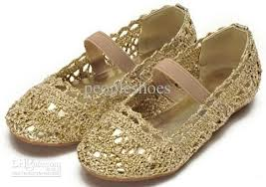](http://www.google.com/imgres?imgurl=http://www.dhresource.com/albu_254776404_00-1.0x0/little-girls-shoes-hollow-style-shoes-gold.jpg&imgrefurl=http://www.dhgate.com/hot-product/hot-little-girls-shoes.html&h=414&w=587&tbnid=F_xFGVwkuw-0zM:&zoom=1&docid=yLsAcWD3plQPaM&hl=en&ei=klp6U_uBMM-3yASi54GgBg&tbm=isch&ved=0CCsQMygjMCM42AQ&iact=rc&uact=3&dur=1072&page=64&start=634&ndsp=12)

[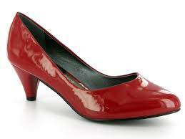](http://www.google.com/imgres?imgurl=http://upload.wikimedia.org/wikipedia/en/b/bd/Ladies-shoes-hd-photos.jpg&imgrefurl=http://en.wikipedia.org/wiki/File:Ladies-shoes-hd-photos.jpg&h=600&w=800&tbnid=8g8ftWEgLRWgjM:&zoom=1&docid=w1PEemzdlov8fM&hl=en&ei=J1h6U7_sCIqoyASS3YKgBA&tbm=isch&ved=0CKMBEDMoNDA0&iact=rc&uact=3&dur=559&page=6&start=46&ndsp=9)[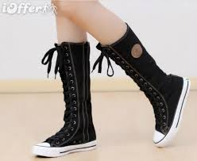](http://www.google.com/imgres?imgurl=http://www.ioffer.com/img/item/536/767/092/women-knee-high-canvas-boots-sneakers-shoes-girls-shoes-be66.jpg&imgrefurl=https://www.ioffer.com/c/Women-s-Shoes-1010293/Boots&h=476&w=580&tbnid=fNuytgkb5nQgAM:&zoom=1&docid=lqoNxnj9v9RdRM&hl=en&ei=EVl6U-XgBs2fyAS5xYGQDg&tbm=isch&ved=0CGYQMyheMF44yAE&iact=rc&uact=3&dur=374&page=30&start=286&ndsp=10) [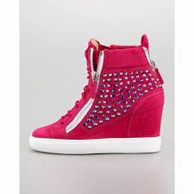](http://www.google.com/imgres?imgurl=http://www.giuseppezanottidesigner.com/images/Giuseppe-Zanotti-UK/Giuseppe-Zanotti-Crystal-Suede-Wedge-Sneakers-In-Peach.jpg&imgrefurl=http://www.giuseppezanottidesigner.com/giuseppe-zanotti-sneakers-outlet-2.html&h=980&w=980&tbnid=M35yGJHEna9MDM:&zoom=1&docid=WYPlGKORevhk8M&hl=en&ei=rS-NU7SFJ9WpyATVhoKIDw&tbm=isch&ved=0CJ0BEDMoVzBX&iact=rc&uact=3&dur=2804&page=5&start=79&ndsp=23)[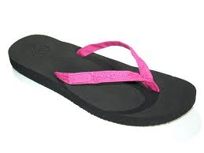](http://www.google.com/imgres?imgurl=http://www.flipflopstyle.com/wp-content/uploads/2012/02/1660-ginger-hot-pink_717_detail.jpg&imgrefurl=http://www.flipflopstyle.com/&h=450&w=600&tbnid=F1QqfI2mxOx1YM:&zoom=1&docid=KZ6YameZuoBt7M&hl=en&ei=LjONU7PoDYGjyASdn4DgCQ&tbm=isch&ved=0CHAQMygnMCc&iact=rc&uact=3&dur=3691&page=3&start=38&ndsp=23)[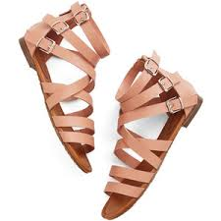](http://www.google.com/imgres?imgurl=http://www.polyvore.com/cgi/img-thing?.out=jpg&size=l&tid=106216754&imgrefurl=http://www.polyvore.com/sandals/thing?id=48306916&h=300&w=300&tbnid=I9bp1TNepXddKM:&zoom=1&docid=izC6bjVD9bfwqM&hl=en&ei=rjSNU6OvC462yATH8oLIAQ&tbm=isch&ved=0CCgQMyggMCA49AM&iact=rc&uact=3&dur=539&page=25&start=515&ndsp=24)[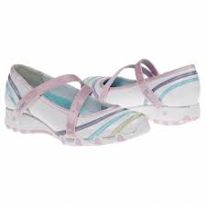](http://www.google.com/imgres?imgurl=http://shoesmypassion.com/wp-content/uploads/2013/01/skechers-shoes.jpg&imgrefurl=http://shoesmypassion.com/stylish-and-comfortable-shoes-for-a-little-lady/&h=350&w=350&tbnid=RMH---tOY9kzrM:&zoom=1&docid=-RJ-OyhvGg20SM&hl=en&ei=WjGNU7qLL4y2yATsgoGQDw&tbm=isch&ved=0CJsBEDMoUjBS&iact=rc&uact=3&dur=881&page=5&start=77&ndsp=23)[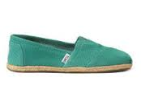](http://www.google.com/imgres?imgurl=http://www.toms.com/static/www/images/product/product_image_218x153_Side/GreenSheenPerforatedSuedeWomensClassics-10001416-S_218x153.jpg&imgrefurl=http://www.toms.com/women/womens-shoes&h=153&w=218&tbnid=NSrjQoRBCxxYNM:&zoom=1&docid=W7VYtvgY5LQerM&itg=1&hl=en&ei=hSuNU43cMce1yATntIGACA&tbm=isch&ved=0CFwQMyhUMFQ4oAY&iact=rc&uact=3&dur=3521&page=42&start=883&ndsp=27)[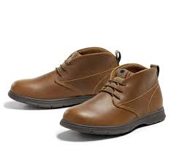](http://www.google.com/imgres?imgurl=http://g-ec2.images-amazon.com/images/G/01/AMAZON_FASHION/2014/WAYFINDING/EDITORIAL/BTS_2/BOYS/SHOES/PERIPHERALS/VD/BTS2_boys_boots_VD._V345033159_.jpg&imgrefurl=http://www.amazon.com/Boys-Shoes/b?ie=UTF8&node=679182011&h=450&w=520&tbnid=wtnm8bqXE3uMxM:&zoom=1&docid=KAOLTJn2StVxbM&hl=en&ei=Jf_xU6OjKJCxyAT0lYDgCQ&tbm=isch&ved=0CFkQMygcMBw&iact=rc&uact=3&dur=325&page=2&start=12&ndsp=24)[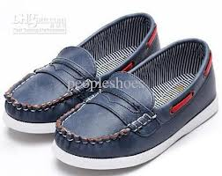](http://www.google.com/imgres?imgurl=http://image.dhgate.com/albu_284924791_00-1.0x0/brown-shoes-school-boys-shoes-three-color.jpg&imgrefurl=http://www.dhgate.com/store/product/brown-shoes-school-boys-shoes-three-color/149203418.html&h=356&w=450&tbnid=X1rLQ4M4WUlPaM:&zoom=1&docid=7WW-Z3Rs1XDzHM&hl=en&ei=Jf_xU6OjKJCxyAT0lYDgCQ&tbm=isch&ved=0CF8QMygiMCI&iact=rc&uact=3&dur=584&page=2&start=12&ndsp=24)[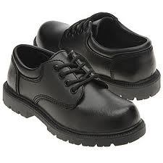](http://www.google.com/imgres?imgurl=http://www.your-pk.com/images/shoes/boys%20shoes/boys%20dress-07.jpg&imgrefurl=http://www.your-pk.com/shoes%20design.htm&h=350&w=350&tbnid=RBYc2VJAnPyXcM:&zoom=1&docid=Jn9KHiXf7XmlxM&hl=en&ei=Jf_xU6OjKJCxyAT0lYDgCQ&tbm=isch&ved=0CFYQMygZMBk&iact=rc&uact=3&dur=1102&page=2&start=12&ndsp=24)[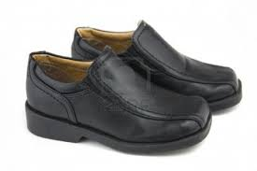](http://www.google.com/imgres?imgurl=http://us.123rf.com/400wm/400/400/joingate/joingate1001/joingate100100079/6258193-luttle-boys-formal-black-shoes-for-toddler.jpg&imgrefurl=http://www.123rf.com/photo_6258193_luttle-boys-formal-black-shoes-for-toddler.html&h=801&w=1200&tbnid=DnI2AwvrYK9SNM:&zoom=1&docid=9EZVNPxANI9ovM&hl=en&ei=uv_xU8eXEIaTyATO5ICwBg&tbm=isch&ved=0CIoBEDMoTTBN&iact=rc&uact=3&dur=461&page=5&start=77&ndsp=23)[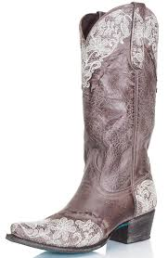](http://www.google.com/imgres?imgurl=http://feeds2.yourstorewizards.com/2084/images/full/lane-womens-boots-jani-lace-lb0168c.jpg&imgrefurl=http://www.langstons.com/lane-boots.html&h=1000&w=652&tbnid=dq_rh7-WR7NkDM:&zoom=1&docid=JPwosEuC_Lq6dM&hl=en&ei=sC2NU9aeG9WkyAT68oCQAg&tbm=isch&ved=0CGUQMyhdMF049AM&iact=rc&uact=3&dur=517&page=25&start=569&ndsp=27)[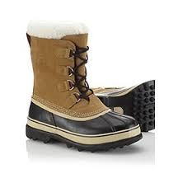](http://www.google.com/imgres?imgurl=http://s7d5.scene7.com/is/image/ColumbiaSportswear/NM1000_281_f?$pgrid_med$&defaultImage=sorel_unavailable&imgrefurl=http://www.sorel.com/mens-caribou-boot-NM1000.html&h=270&w=270&tbnid=AltrLH1KcTRkCM:&zoom=1&docid=Kdp169bx2HdTtM&itg=1&hl=en&ei=XC6NU8rgFY-wyAT_t4DQCQ&tbm=isch&ved=0CA4QMygGMAY4oAY&iact=rc&uact=3&dur=594&page=35&start=802&ndsp=19)[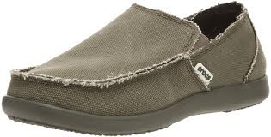](http://www.google.com/imgres?imgurl=http://4.bp.blogspot.com/-P5nBHBasbms/T_sEg6NzcuI/AAAAAAAAB8c/0eFxPakR8nw/s1600/crocs+Men's+Santa+Cruz+Slip-On+01.jpg&imgrefurl=http://crocs-shoes-at.blogspot.com/2012/07/crocs-mens-santa-cruz-slip-on.html&h=764&w=1500&tbnid=k43nCMZNDPW_PM:&zoom=1&docid=AdULnCYIK7gG-M&hl=en&ei=ejKNU8G0OoWyyATl1oA4&tbm=isch&ved=0CGwQMygjMCM&iact=rc&uact=3&dur=449&page=3&start=30&ndsp=20)[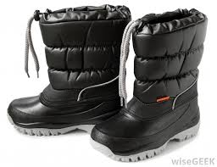](http://www.google.com/imgres?imgurl=http://images.wisegeek.com/black-slip-on-snow-boots.jpg&imgrefurl=http://www.wisegeek.com/what-are-the-different-types-of-slip-on-boots.htm&h=772&w=1000&tbnid=O_cT3pjLAGmxiM:&zoom=1&docid=fQ-y2efLMw0aEM&hl=en&ei=sC2NU9aeG9WkyAT68oCQAg&tbm=isch&ved=0CCAQMygYMBg49AM&iact=rc&uact=3&dur=644&page=23&start=518&ndsp=25)[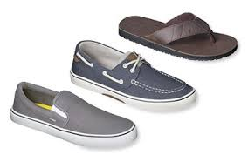](http://www.google.com/imgres?imgurl=https://tgtfiles.target.com/refresh-tool/656-140413.jpg&imgrefurl=http://www.target.com/c/shoes-men/-/N-5xu1w&h=235&w=375&tbnid=YhnrQUegvgtx8M:&zoom=1&docid=YBul0NMeaKR_cM&itg=1&hl=en&ei=bCuNU8PiH8aSyATC-oLADQ&tbm=isch&ved=0CGsQMyhjMGM4vAU&iact=rc&uact=3&dur=950&page=38&start=784&ndsp=23)[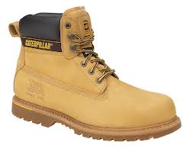](http://www.google.com/imgres?imgurl=http://media.brixworkwear.com/media/catalog/product/cache/1/image/9df78eab33525d08d6e5fb8d27136e95/1/2/12808catholtonhoney.jpg&imgrefurl=http://www.survivalistboards.com/showthread.php?t=322726&page=3&h=882&w=1124&tbnid=4pJ7lg83wJZXpM:&zoom=1&docid=py09wCgELCSfzM&hl=en&ei=USyNU7j7E5C3yATB24DYAw&tbm=isch&ved=0CIMBEDMoPTA9&iact=rc&uact=3&dur=794&page=4&start=61&ndsp=19)[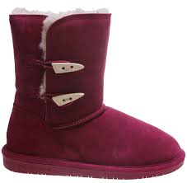](http://www.google.com/imgres?imgurl=http://images.the-house.com/bearpaw-abigail-wmns-boot-pom-berry-14.jpg&imgrefurl=http://www.the-house.com/casual-boots-womens.html&h=1500&w=1532&tbnid=7Y3OQNU0UZqmYM:&zoom=1&docid=TW4IlPOIBLSzxM&hl=en&ei=USyNU7j7E5C3yATB24DYAw&tbm=isch&ved=0CJABEDMoSjBK&iact=rc&uact=3&dur=607&page=4&start=61&ndsp=19)[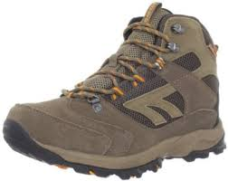](http://www.google.com/imgres?imgurl=http://ecx.images-amazon.com/images/I/41uvwQwMUrL._SX395_.jpg&imgrefurl=http://www.amazon.com/Hi-Tec-Mens-Flagstaff-Waterproof-Hiking/dp/B008RIKYJO&h=313&w=395&tbnid=ttcXERiCGjiifM:&zoom=1&docid=K-bnHZh0PGlp5M&hl=en&ei=sC2NU9aeG9WkyAT68oCQAg&tbm=isch&ved=0CFMQMyhLMEs49AM&iact=rc&uact=3&dur=526&page=25&start=569&ndsp=27)[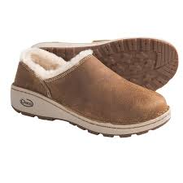](http://www.google.com/imgres?imgurl=http://i.stpost.com/chaco-zaagh-baa-shoes-leather-for-women-in-sienna~p~4915m_02~1500.2.jpg&imgrefurl=http://www.sierratradingpost.com/chaco-zaagh-baa-shoes-leather-for-women~p~4915m/reviews/&h=1500&w=1500&tbnid=EhxMVxEJL_RhtM:&zoom=1&docid=D8d7AlPP9kvQQM&hl=en&ei=9Fl6U6GrCNOayASlw4CAAg&tbm=isch&ved=0CAkQMygBMAE4kAM&iact=rc&uact=3&dur=1041&page=41&start=401&ndsp=9)